Live IOT machine data using Augmented reality

SESAP ZG628T PROJECT WORK

By

Aravind Prabhu

2017SP93044

Dissertation work carried out at

SAP Labs, Bangalore

A drawing of a cartoon character

Description generated with high confidence

BIRLA INSTITUTE OF TECHNOLOGY AND SCIENCE

Pilani (Rajasthan) INDIA

(June 2019)

SE SAP ZG628T DISSERTATION

Live IOT machine data using Augmented reality

Submitted in partial fulfillment of the requirements of the

M. Tech. Software Engineering Degree Programme

By

Aravind Prabhu

2017SP93044

Under the supervision of

Sumeet Raj (Senior Developer)

Dissertation work carried out at

SAP Labs, Bangalore

A drawing of a cartoon character

Description generated with high confidence

BIRLA INSTITUTE OF TECHNOLOGY AND SCIENCE

PILANI (RAJASTHAN)

(June 2019)

**BIRLA INSTITUTE OF TECHNOLOGY AND SCIENCE, PILANI**

**CERTIFICATE**

This is to certify that the Project Work entitled Live IOT machine data using Augmented reality submitted by Aravind Prabhu ID No. 2017SP93044 in partial fulfillment of the requirements of SESAP ZG628T Project Work, embodies the work done by him under my supervision.



Signature of the Supervisor

Name : Sumeet Raj

Date: 05 July 2019 Designation : Senior Developer

Acknowledgement

I have taken efforts in this project. However, it would not have been possible without the kind support and help of many individuals and organizations. I would like to extend my sincere thanks to all of them.

I am highly indebted to Sumeet Raj for the guidance and constant supervision as well as for providing necessary information regarding the project & also for the support in completing the project.

Many thanks to Professor Vadivelan M for guiding me throughout the effort of this project. His continuous feedback and direction has helped this project reach its best form.

I would like to express my gratitude towards my parents & member of SAP for their kind co-operation and encouragement which help me in completion of this project.

**Index**

List of Figures 6

Abstract 7

Problem Statement 8

Business Process Flow 8

Objectives 9

Uniqueness of the project 9

Benefits to the organization 9

Scope of Work 9

Resources Needed 10

Potential Challenges and Risks 11

Solution Architecture 12

IOT Service 12

Augmented Reality WebApp 15

Screenshots 17

Conclusion 18

Directions for future work 19

Detailed Plan of Work 20

Plan for Remainder of the project 22

References 23

# List of Figures

|  |  |  |
| --- | --- | --- |
| **Sl. No** | **Figure** | **Page Number** |
| 1 | Solution Architecture | 12 |
| 2 | IOT Service API Endpoint | 13 |
| 3 | Circuit Connection | 13 |
| 4 | A sample Marker | 16 |
| 5 | Screenshots | 17 |

**BIRLA INSTITUTE OF TECHNOLOGY & SCIENCE, PILANI**

**SECOND SEMESTER 2018-19**

**SESAP ZG629T DISSERTATION**

Dissertation Title: Live IOT machine data using Augmented reality

Name of Supervisor: Sumeet Raj (Senior Developer)

Name of Student: Aravind Prabhu

ID No. of Student: 2017SP93044

## Abstract

The main objective of the project is to make peoples life easier and to improve the business process. With the help of augmented reality now we can see the live data of a machine and know its state. So, this will help in maintenance of the machineries and to speed up the business process. There will be 8.4 billion connected things in 2017, setting the stage for 20.4 billion Internet of Things (IoT) devices to be deployed by 2020, according to analyst firm Gartner. So, with IOT and Augmented reality together we can get the information about the device/machine in front of you with ease and it will help in improving the efficiency of the business process .Smart engineering processes can save manufacturers millions of dollars by identifying potential flaws in products before they ship, in addition to reducing the time to ship a product. As the data in the world is exploding drastically, now data has become power. Also, the way we can access data also has changed over time. Now everyone has so much computation power in their hand that everything they need is available at a single click.

But even then, to get some information we must search online and surf through lots of webpages just for a simple task in like getting price of an item. In business domain also, we must go to a monitoring dashboard and do many clicks to know the to get current state of machine which is in front of you. So, this is an overhead which can be avoided and can be improved to make life easier.

(Signature of Supervisor) (Signature of Student)

# Problem Statement

As the data in the world is exploding drastically, now data has become power. Also, the way we can access data also has changed over time. Now everyone has so much computation power in their hand that everything they need is available at a single click.

But even then, to get some information we must search online and surf through lots of webpages just for a simple task in like getting price of an item. In business domain also, we must go to a monitoring dashboard and do many clicks to know the to get current state of machine which is in front of you. So, this is an overhead which can be avoided and can be improved to make life easier.

# Business Process Flow

The business flow would have the following:

* The IOT machine data will be streamed to the IOT service .
* The Machine floor manager can walk up to the machine and get the live data in the web interface .
* The Augmented reality is also integrated in the web interface.
* Using the Augmented reality web interface, the Machine floor manager can open the web application in his hand-held device and can see the status of the machine.

# Objectives

The main objective of the project is to make peoples life easier and to improve the business process. With the help of augmented reality now we can see the live data of a machine and know its state. So, this will help in maintenance of the machineries and to speed up the business process. There will be 8.4 billion connected things in 2017, setting the stage for 20.4 billion Internet of Things (IoT) devices to be deployed by 2020, according to analyst firm Gartner. So, with IOT and Augmented reality together we can get the information about the device/machine in front of you with ease and it will help in improving the efficiency of the business process .Smart engineering processes can save manufacturers millions of dollars by identifying potential flaws in products before they ship, in addition to reducing the time to ship a product.

# Uniqueness of the project

There are solutions focused on IOT or Augmented reality but their adoption in industry is very less. There are some solutions offered by companies like ptc and L2 Technology Services, but they are focused on the process of fixing/repairing of the equipment and not on the machine details at current time. The idea in this project is to make an AR solution which can integrate to any type of IOT device.

# Benefits to the organization

SAP is leading in terms of adapting unique and upcoming technology solutions to help the world run better. There is currently no solution combining both IOT and the Augmented reality. Also, this coincides with SAP’s vision that is, to help world run better and improve people’s life.

# Scope of Work

The Augmented reality will be an Android app which will communicate with this Gateway service that will be deployed on Cloud foundry to get the data. Also, Hardware sensors will be used to send data to gateway. So main scope of this project is the Augmented reality application showing the IOT data .The IOT sensor and the gateway services that will be built will help in showing the end to end scenario of the application.

# Resources Needed

|  |  |
| --- | --- |
| Software (Frameworks, Cloud platform) | 1. AR.js framework. 2. Spring boot. 3. Cloud Foundry Account. |
| Hardware | 1. Any Windows PC 2. Node MCU 3. Temperature Sensor 4. Humidity Sensor |

# Potential Challenges and Risks

1. We are going to deploy our IOT Gateway service to in cloud platform, so there might be an issue in terms of data access when the cloud is down.
2. Making the android app efficient to get the real time data.
3. Choosing current AR framework to work with android.
4. Potential challenges in managing IOT sensor data.
5. Time required to learn and adopt the Augment reality framework.

# Solution Architecture

Architecture diagram of the application:

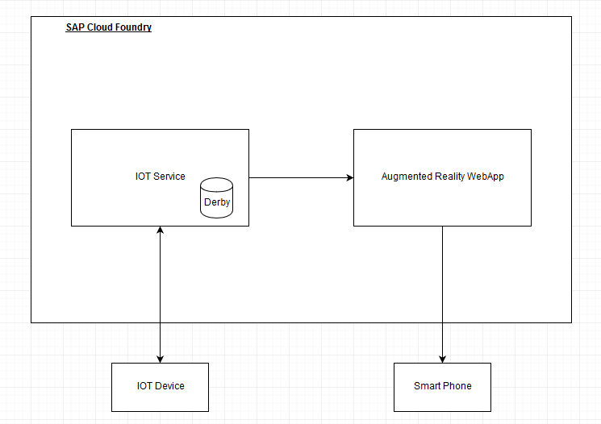

Fig 1 :Solution Architecture

This Architecture has two main components:

* IOT Service
* Augmented Reality Service/ Web App

# IOT Service

This service is where the IOT devices push data and the IOT service provides the device management and the persistent of the Realtime data. This data is used to create analytics and create alerts for the device. This is the core service which is the OT(Operational Technology) part of the IOT. In fact, it’s one of the essences of the IoT (although IT and OT convergence goes back earlier, certainly in some of the just mentioned areas). Yet, with IoT is happening faster and at a broader scale than before and Gartner’s words become more actual than ever. In case you’re not familiar with the – by now – ‘good old’ IT versus OT debate: IT is what you think it is. Information technology or the corporate IT team, led by a CIO. OT is operational technology as we’ll see but it’s in the mix of both that interesting things happen. Of the previously mentioned markets IT and OT integration is, for instance, key in building management in the age of IoT.

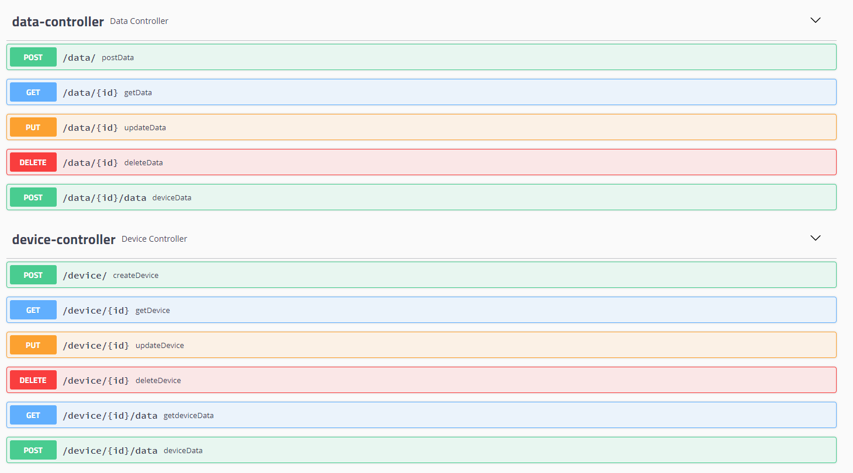

Fig 2 :IOT Service API Endpoint

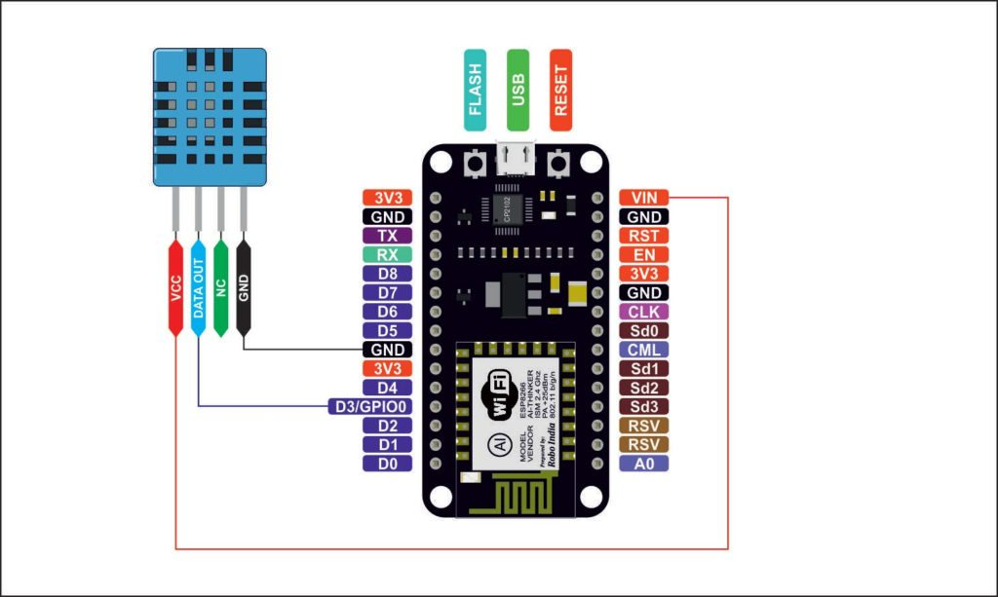

Fig 3 : Circuit Connection

**DHT11**:

The DHT11 is chosen because it is lab calibrated, accurate and stable and its signal output is digital. Most important of all, it is relatively inexpensive for the given performance. It can measure relative humidity in percentage (20 to 90% RH) and temperature in degree Celsius in the range of 0 to 50°C.It has 4 pins; one of which is used for data communication in serial form. Pulses of different TON and TOFF are decoded as logic 1 or logic 0 or start pulse or end of frame.

**Node MCU**:

NodeMCU is an open source LUA based firmware developed for ESP8266 wifi chip. By exploring functionality with ESP8266 chip, NodeMCU firmware comes with ESP8266 Development board/kit i.e. NodeMCU Development board. Since NodeMCU is open source platform, their hardware design is open for edit/modify/build.NodeMCU Dev Kit/board consist of ESP8266 Wi-Fi enabled chip. The ESP8266 is a low-cost Wi-Fi chip developed by Espressif Systems with TCP/IP protocol. As the operating voltage range of ESP8266 is 3V to 3.6V, the board comes with a LDO voltage regulator to keep the voltage steady at 3.3V. It can reliably supply up to 600mA, which should be more than enough when ESP8266 pulls as much as 80mA during RF transmissions. The output of the regulator is also broken out to one of the sides of the board and labeled as 3V3. This pin can be used to supply power to external components.

# Augmented Reality WebApp

This augmented reality service is a browser-based application which does not need any application to be explicitly installed on the device .This is based on a JavaScript library AR.js which provides the augmented reality capability. AR.js is a solution for efficiently doing augmented reality on the web. This AR.js used A-frame for its rendering . A-Frame is a web framework for building virtual reality (VR) experiences. A-Frame is based on top of HTML, making it simple to get started. But A-Frame is not just a 3D scene graph or a markup language; the core is a powerful entity-component framework that provides a declarative, extensible, and composable structure to three.js. AR that can be easily experienced on today’s phones and easily designed using web technology. The AR.js project is about enabling those people. So now, anybody with a modern phone can enjoy open-source AR, free of charge, cross-platform and without installation.

Augmented Reality (AR) brings digital information and virtual objects into the physical space. With AR, the digital world comes to life inside the view captured by your tablet or phone camera. This article is for those who want to dig deeper into how we can trigger the display of digital content. Read our other article on “how does AR work” if you want to know more about the technology that allows AR to come to life. There are several key questions we must ask before a user can interact with the digital world. What content do we display on the live camera view? And where exactly should we put that content within the user’s view? The answer to these questions depends on which application of AR you choose, as each requires different types of user interaction. In some cases, we need to know exactly what the user is looking at, we call this “marker-based AR”. In other instances, we just need to display 3D augmented reality models, which we can do without a marker, so we call it “markerless AR”. Finally, in a few instances we need to provide local information, such as walking directions or road signs. In this case we need to know the user’s location, so we use “location-based AR”. As marker-based AR is more reliable and for that reason they are used in majority of the augmented reality scenarios. For this project I have used the marker-based AR to make the augmented reality more reliable.

**Marker-based Augmented Reality**:

A marker is giving the Augmented Reality (AR) application a visual clue or trigger where to position AR content. The marker can be an image, a logo or any type of distinguishable 2D object that can be recognized by the camera. Due to its use of image recognition, this type of AR is sometimes also called recognition-based AR. The quality of the image that is being used as an AR trigger is important. Quality does not necessarily refer to resolution but to how recognizable the marker is for the camera and the underlying image recognition software. Important aspects are the contrast, number of lines, texture changes etc. The quality of the marker depends on the number of key points that are found when pre-processing the marker. The more visual details a marker has, the better it is going to work.



Fig 4 : A simple marker

A camera is used with AR software to detect augmented reality markers as the location for virtual objects. The result is that an image can be viewed, even live, on a screen and digital assets are placed into the scene at the location of the markers. Limitations on the types of augmented reality markers that can be used are based on the software that recognizes them. While they need to remain simple for error correction, they can include a wide range of different images. The simplest types of augmented reality markers are black and white images that consist of two-dimensional (2D) barcodes.

# Screenshots

|  |  |
| --- | --- |
| C:\Users\I341573\Downloads\WhatsApp Image 2019-06-26 at 9.12.37 PM.jpeg | C:\Users\I341573\Downloads\WhatsApp Image 2019-06-26 at 9.12.37 PM (1).jpeg |

|  |  |
| --- | --- |
| C:\Users\I341573\Downloads\WhatsApp Image 2019-06-26 at 9.12.37 PM (2).jpeg | C:\Users\I341573\Downloads\WhatsApp Image 2019-06-26 at 9.12.37 PM (3).jpeg |

# Conclusion

This aim of this project was show the integration between augmented reality and the IOT device and a seamless flow and interaction between both with the augmented reality must be rendered in the browser and doesn’t need a augmented reality specific device or an application to be installed.

* The Augmented reality application is completely browser based.
* The Augmented reality application supports multiple device with its own marker to render its dat.
* The IOT device pushes the live data into the IOT service.
* The Augmented reality application displays the live data in to an browser with its device model when it identifies the marker of that device.

# Directions for future work

Some enhancements need to be made to make the device model rendering into the Brower.

Also, this project can be extended into many scenarios such as:

* One Machine with multiple markers on each part so we can show only the data of that part.
* Show how-to do a task in the augmented reality service , which can be used to fix the machine parts by following the steps shown in the augmented reality service.
* Optimize and use geo-location-based marker in a smaller space instead of marker based augmented reality.

# Detailed Plan of Work

|  |  |  |  |
| --- | --- | --- | --- |
| # | Task Name | Expected date of completion | Deliverables |
| 1 | Validation of Augmented reality Framework | 18 Feb | Testing multiple AR frameworks |
| 2 | Browser Based AR Validation | 25 Feb | Browser Based AR sample test code |
| 3 | Designing the Flow | 4 Mar | Design the classes and interfaces for the application |
| 4 | Documentation | 11 Mar | Create initial versions of documentation |
| 5 | IOT Service Initial Setup | 11 Mar | IOT Service Design |
| 6 | IOT Service Prototype Development | 20 Mar | IOT Service prototype Implementation |
| 7 | Cloud Foundry Deployment of IOT Service | 28 Mar | Application hosted on Cloud foundry |
| 8 | Prototype of Augmented Reality Design | 30 Mar | Designing and prototyping the Augmented Reality App |
| 9 | Integration of IOT service and Augmented Reality App | 1 April | Integration of IOT service and Augmented Reality service. |
| 10 | Deployment of Augmented reality to Cloud foundry | 3 April | Augmented Service hosted to Cloud foundry |
| 11 | Testing the end to end sample scenario | 4 April | Testing sample low level integration. |
| 12 | Enhancing the IOT service | 8 April | IOT Service Enhancement. |
| 13 | Hardware Connection to IOT service | 20 April | Streaming of data from hardware sensors to IOT service. |
| 14 | Testing | 22 April | Perform end to end tests and bug fixes |
| 15 | Enhance the Augmented Reality application | 29 April | Multiple IOT devices Marker detection |
| 16 | Multiple Sensors to Hardware | 17 Jun | Testing with Multiple Sensors |
| 17 | Bug fixes | 21 Jun | Fix issues during tests, continue till zero bugs found |
| 18 | Documentation | 26 Jun | Update documentation for missing information (if any). |

**Completed Work**

|  |  |  |  |
| --- | --- | --- | --- |
| # | Task Name | Expected date of completion | Deliverables |
| 1 | Validation of Augmented reality Framework | 18 Feb | Testing multiple AR frameworks |
| 2 | Browser Based AR Validation | 25 Feb | Browser Based AR sample test code |
| 3 | Designing the Flow | 4 Mar | Design the classes and interfaces for the application |
| 4 | Documentation | 11 Mar | Create initial versions of documentation |
| 5 | IOT Service Initial Setup | 11 Mar | IOT Service Design |
| 6 | IOT Service Prototype Development | 20 Mar | IOT Service prototype Implementation |
| 7 | Cloud Foundry Deployment of IOT Service | 28 Mar | Application hosted on Cloud foundry |
| 8 | Prototype of Augmented Reality Design | 30 Mar | Designing and prototyping the Augmented Reality App |
| 9 | Integration of IOT service and Augmented Reality App | 1 April | Integration of IOT service and Augmented Reality service. |
| 10 | Deployment of Augmented reality to Cloud foundry | 3 April | Augmented Service hosted to Cloud foundry |
| 11 | Testing the end to end sample scenario | 4 April | Testing sample low level integration. |

# Plan for Remainder of the project

|  |  |  |  |
| --- | --- | --- | --- |
| # | Task Name | Expected date of completion | Deliverables |
| 1 | Testing the end to end sample scenario | 4 April | Testing sample low level integration. |
| 2 | Enhancing the IOT service | 8 April | IOT Service Enhancement. |
| 3 | Hardware Connection to IOT service | 20 April | Streaming of data from hardware sensors to IOT service. |
| 4 | Testing | 22 April | Perform end to end tests and bug fixes |
| 5 | Enhance the Augmented Reality application | 29 April | Multiple IOT devices Marker detection |
| 6 | Multiple Sensors to Hardware | 17 Jun | Testing with Multiple Sensors |
| 7 | Bug fixes | 21 Jun | Fix issues during tests, continue till zero bugs found |
| 8 | Documentation | 26 Jun | Update documentation for missing information (if any). |

# References

* A-frame - https://aframe.io/docs/0.7.0/introduction/
* Three.js- https://threejs.org/docs/#manual/en/introduction/Creating-a-scene
* Web VR - https://glitch.com/culture/an-intro-to-webvr/
* Spring boot - https://spring.io/projects/spring-boot
* Cloud Foundry - https://www.cloudfoundry.org/
* SAP Cloud Platform - <https://cloudplatform.sap.com/index.html>

**Copyright**

© 2012 SAP AG. All rights reserved.

No part of this publication may be reproduced or transmitted in any form or for any purpose without the express permission of SAP AG. The information contained herein may be changed without prior notice.

Some software products marketed by SAP AG and its distributors contain proprietary software components of other software vendors .Microsoft, Windows, Excel, Outlook, PowerPoint, Silverlight, and Visual Studio are registered trademarks of Microsoft Corporation.

IBM, DB2, DB2 Universal Database, System i, System i5, System p, System p5, System x, System z, System z10, z10,z/VM, z/OS, OS/390, zEnterprise, PowerVM, Power Architecture, Power Systems, POWER7, POWER6+, POWER6,POWER, PowerHA, pureScale, PowerPC, BladeCenter, System Storage, Storwize, XIV, GPFS, HACMP, RETAIN, DB2 Connect, RACF, Redbooks, OS/2, AIX, Intelligent Miner, WebSphere, Tivoli, Informix, and Smarter Planet are trademarks or registered trademarks of IBM Corporation.

Adobe, the Adobe logo, Acrobat, PostScript, and Reader are trademarks or registered trademarks of Adobe Systems

Incorporated in the United States and other countries.

UNIX, X/Open, OSF/1, and Motif are registered trademarks of the Open Group.

Citrix, ICA, Program Neighborhood, MetaFrame, WinFrame, VideoFrame, and MultiWin are trademarks or registered trademarks of Citrix Systems Inc.

HTML, XML, XHTML, and W3C are trademarks or registered trademarks of W3C®, World Wide Web Consortium, Massachusetts Institute of Technology.

IOS is a registered trademark of Cisco Systems Inc.

RIM, BlackBerry, BBM, BlackBerry Curve, BlackBerry Bold, BlackBerry Pearl, BlackBerry Torch, BlackBerry Storm, BlackBerry Storm2, BlackBerry PlayBook, and BlackBerry App World are trademarks or registered trademarks of Research in Motion Limited.

Computop is a registered trademark of Computop Wirtschaftsinformatik GmbH.

SAP, R/3, SAP NetWeaver, Duet, PartnerEdge, ByDesign, SAP BusinessObjects Explorer, StreamWork, SAP HANA, and other SAP products and services mentioned herein as well as their respective logos are trademarks or registered trademarks of SAP AG in Germany and other countries.

Sybase and Adaptive Server, iAnywhere, Sybase 365, SQL Anywhere, and other Sybase products and services mentioned herein as well as their respective logos are trademarks or registered trademarks of Sybase Inc. Sybase is an SAP company. All other product and service names mentioned are the trademarks of their respective companies. Data contained in this document serves informational purposes only. National product specifications may vary.

These materials are subject to change without notice. These materials are provided by SAP AG and its affiliated companies ("SAP Group") for informational purposes only, without representation or warranty of any kind, and SAP Group shall not be liable for errors or omissions with respect to the materials. The only warranties for SAP Group products and services are those that are set forth in the express warranty statements accompanying such products and services, if any. Nothing herein should be construed as constituting an additional warrant.